NAME: __________________________ DATE DUE: ____________
TEACHER: ________________________
Year 10 Science
/16
HOMEWORK SHEET No. – LG .

1. Write a definition:  (a) DNA (name and what it does):  (3)  (b) GENE (name and what it does):  (1)  (c) CHROMOSOME:  (1)  (d) KARYOTYPE: (1) | /6
2. Explain how a simple molecule such as DNA control the function and structures of your body. (Hint – your answer should discuss how DNA, proteins, and your body are linked) | /4
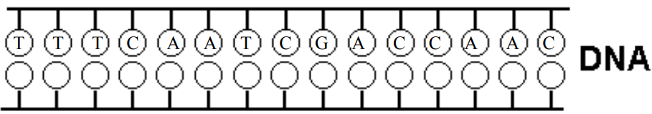  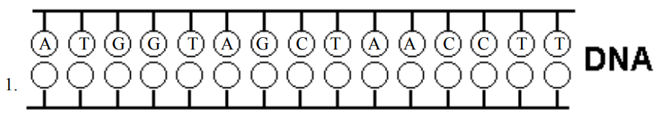  3. Complete the complementary bases in these two very short DNA sequences  What do each of the letters A, T, C, and G stand for? | /6

